Introduction
Each cell of your body is encased in a tiny bubble of membrane, one which has approximately the consistency of salad oil. This might seem like an awfully fragile boundary to place between a cell and the rest of the world, but the plasma membrane is actually very well-suited to its job. It not only defines the borders of the cell, but also allows it to interact with its environment in a controlled way. Cells must exclude some substances, take in others, and excrete still others, all in specific amounts; and they also must be able to communicate with other cells, identifying themselves and sharing information
To perform these roles, the plasma membrane needs lipids, which make a semi-permeable barrier between the cell and its environment. It also needs proteins, which are involved in cross-membrane transport and cell communication, and carbohydrates, which decorate both the proteins and lipids and help cells recognize each other. Here, we’ll take a closer look at the different components of the plasma membrane, examining their roles, their diversity, and how they work together to make a flexible, sensitive, and secure boundary around the cell.

Fluid mosaic model
The currently accepted model for the structure of the plasma membrane, called the fluid mosaic model, was first proposed in 1972. This model has evolved over time, but it still provides a good basic description of the structure and behavior of membranes in many cells. According to the fluid mosaic model, the plasma membrane is a mosaic of components—primarily, phospholipids, cholesterol, and proteins—that can move about freely and fluidly in the plane of the membrane. In other words, a diagram of the membrane (like the one below) is just a snapshot of a dynamic, active process in which phospholipids and proteins are continually sliding past one another, like people milling around in a crowded room at a party. Interestingly enough, this fluidity means that if you insert a very fine needle into a cell, the membrane will simply part to flow around the needle; once the needle is removed, the membrane will flow back together seamlessly.
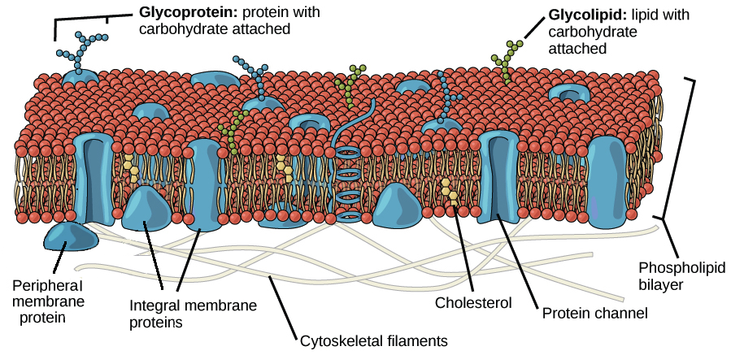
Image of the plasma membrane, showing the phospholipid bilayer with peripheral and integral membrane proteins, glycoproteins (proteins with a carbohydrate attached), glycolipids (lipids with a carbohydrate attached), and cholesterol molecules.
Image modified from OpenStax Biology.
The principal components of the plasma membrane are lipids (phospholipids and cholesterol), proteins, and carbohydrate groups that are attached to some of the lipids and proteins.
- A phospholipid is a lipid made of glycerol, two fatty acid tails, and a phosphate-linked head group. Biological membranes usually involve two layers of phospholipids with their tails pointing inward, an arrangement called a phospholipid bilayer.
- Cholesterol, another lipid composed of four fused carbon rings, is found alongside phospholipids in the core of the membrane.
- Membrane proteins may extend partway into the plasma membrane, cross the membrane entirely, or be loosely attached to its inside or outside face.
- Carbohydrate groups are present only on the outer surface of the plasma membrane and are attached to proteins, forming glycoproteins, or lipids, forming glycolipids.
The proportions of proteins, lipids, and carbohydrates in the plasma membrane vary between different types of cells. For a typical human cell, however, proteins account for about 50 percent of the composition by mass, lipids (of all types) account for about 40 percent, and the remaining 10 percent comes from carbohydrates.

Phospholipids
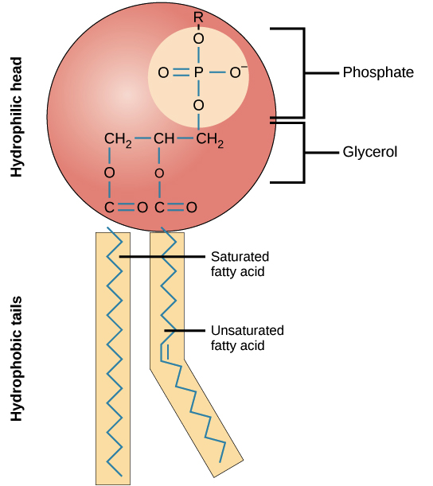
Chemical structure of a phospholipid, showing the hydrophilic head and hydrophobic tails.
Image credit: OpenStax Biology.
Phospholipids, arranged in a bilayer, make up the basic fabric of the plasma membrane. They are well-suited for this role because they are amphipathic, meaning that they have both hydrophilic and hydrophobic regions.
The hydrophilic, or “water-loving,” portion of a phosopholipid is its head, which contains a negatively charged phosphate group as well as an additional small group (of varying identity, “R” in the diagram below), which may also or be charged or polar. The hydrophilic heads of phospholipids in a membrane bilayer face outward, contacting the aqueous (watery) fluid both inside and outside the cell.
The hydrophobic, or “water-fearing,” part of a phospholipid consists of its long, nonpolar fatty acid tails. The fatty acid tails can easily interact with other nonpolar molecules, but they interact poorly with water. Because of this, it’s more energetically favorable for the phospholipids to tuck their fatty acid tails away in the interior of the membrane, where they are shielded from the surrounding water. The phospholipid bilayer formed by these interactions makes a good barrier between the interior and exterior of the cell, because water and other polar or charged substances cannot easily cross the hydrophobic core of the membrane. (Water can in fact cross the plasma membrane, but not very rapidly.)
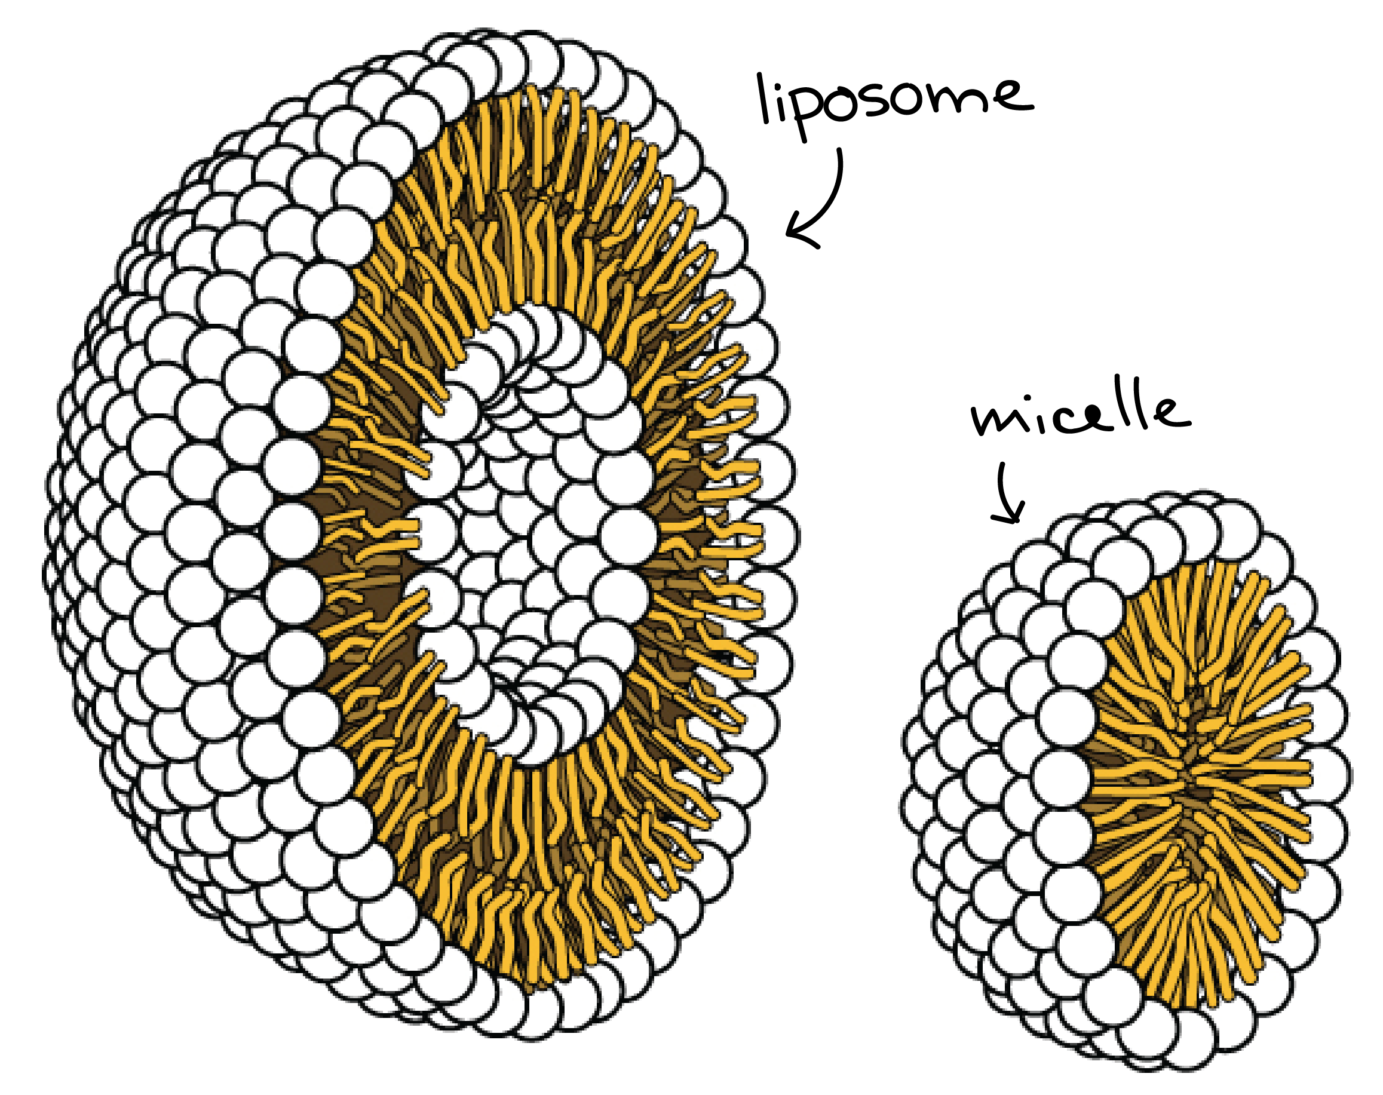
Image of a micelle and a liposome.
Image credit: modification of work by OpenStax Biology, originally by Mariana Ruiz Villareal.
Thanks to their amphipathic nature, phospholipids aren’t just well-suited to form a membrane bilayer. Instead, this is something they’ll do spontaneously under the right conditions! In water or aqueous solution, phospholipids tend to arrange themselves with their hydrophobic tails facing each other and their hydrophilic heads facing out. If the phospholipids have small tails, they may form a micelle (a small, single-layered sphere), while if they have bulkier tails, they may form a liposome (a hollow droplet of bilayer membrane).

Proteins
Proteins are the second major component of plasma membranes. There are two main categories of membrane proteins: integral and peripheral.
Integral membrane proteins are, as their name suggests, integrated into the membrane: they have at least one hydrophobic region that anchors them to the hydrophobic core of the phospholipid bilayer. Some span only part of the membrane, associating with a single layer, while others stretch from one side of the membrane to the other and are exposed on either side (transmembrane proteins).
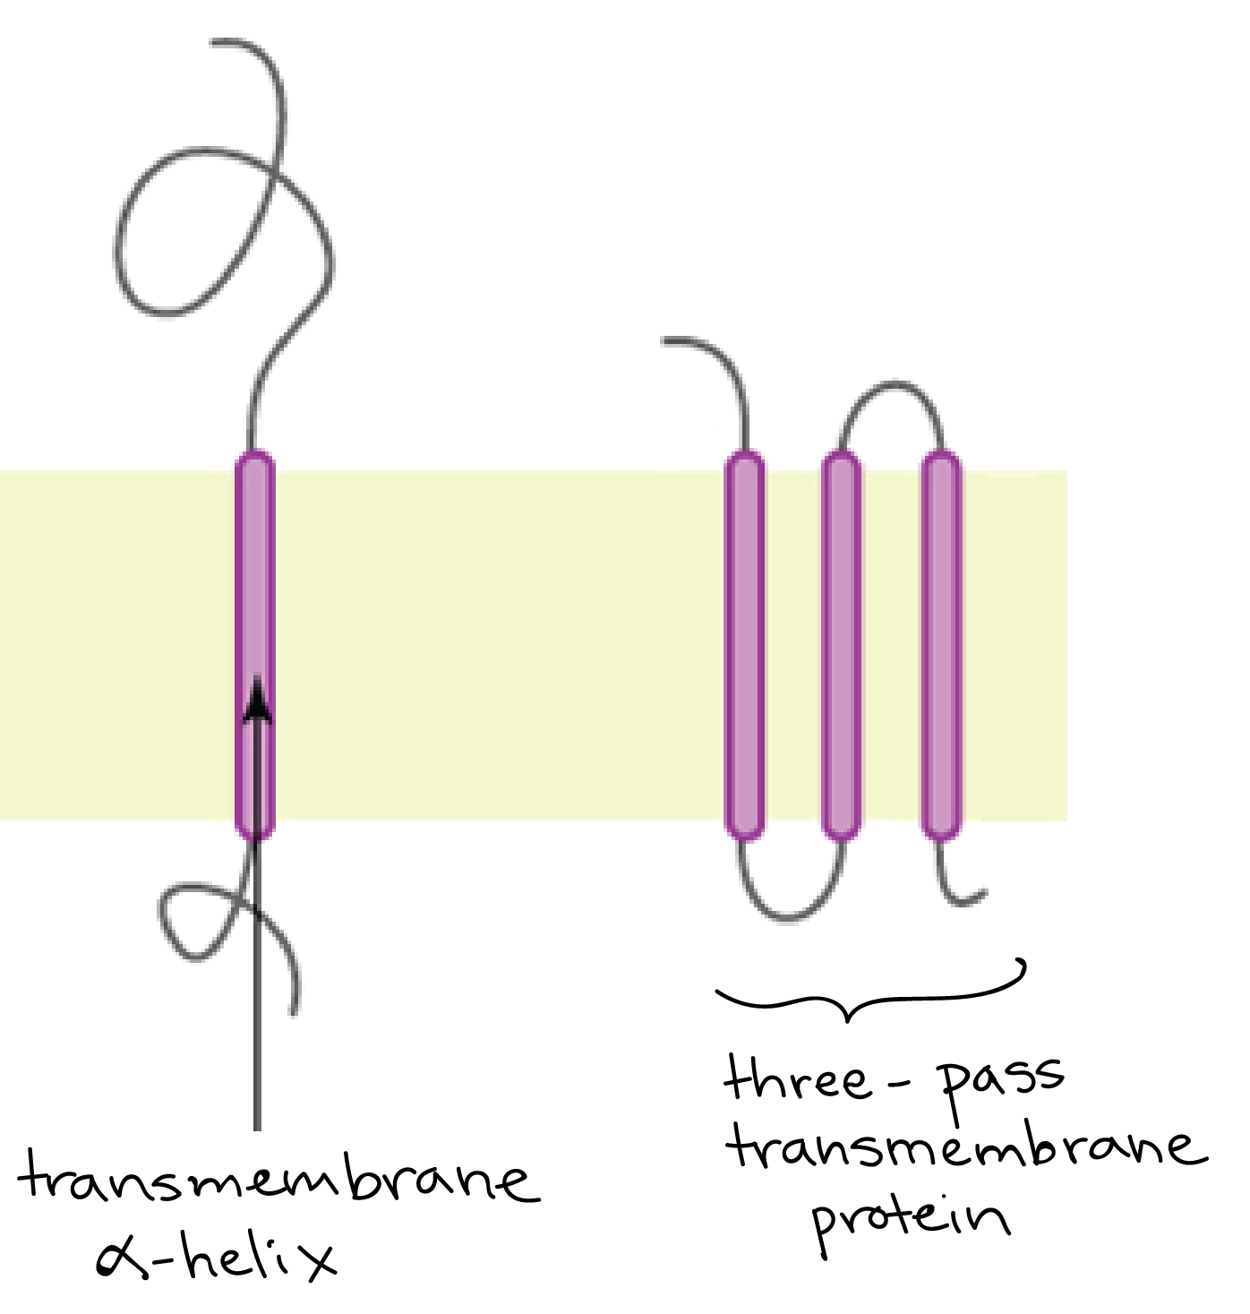
Image of a single-pass transmembrane protein with a single membrane-spanning alpha helix and a three-pass transmembrane protein with three membrane-spanning alpha helices.
Image credit: image modified from OpenStax Biology, originally by Foobar/Wikimedia Commons.
The portions of an integral membrane protein found inside the membrane are hydrophobic, while those that are exposed to the cytoplasm or extracellular fluid tend to be hydrophilic. Transmembrane proteins may cross the membrane just once, or may have as many as twelve different membrane-spanning sections. A typical membrane-spanning segment consists of 20-25 hydrophobic amino acids arranged in an alpha helix, although not all transmembrane proteins fit this model.
Integral membrane proteins are diverse and play a number of important roles in the cell. Some act as ion channels or transporters, selectively allowing certain molecules to pass through the plasma membrane. Others act as receptors, detecting a signal on the outside of the cell and undergoing a conformational change (change in shape) that transmits the signal to the inside of the cell, activating pathways that generate a cellular response. Still others function in cell-cell recognition, help the cell stick to its neighbors or the surrounding matrix, or play structural roles.
Peripheral membrane proteins are found on the outside and inside surfaces of membranes, attached either to integral proteins or to phospholipids. Unlike integral membrane proteins, peripheral membrane proteins do not extend into the hydrophobic core of the membrane, and they tend to be more loosely attached. Peripheral membrane proteins play a number of important roles, like providing attachment sites for cytoskeletal fibers and relaying signals from receptor proteins.

Carbohydrates
Carbohydrates are the third major component of plasma membranes. In general, they are found on the outside surface of cells and are bound either to proteins (forming glycoproteins) or to lipids (forming glycolipids). Surface-exposed carbohydrate chains typically contain fewer than fifteen monosaccharide units, but they can vary in length, sugar type, and branching pattern. Along with membrane proteins, these carbohydrates form distinctive cellular markers, sort of like molecular ID badges, that allow cells to recognize each other. These markers are very important in the immune system, allowing immune cells to differentiate between body cells (which they shouldn’t attack) and foreign cells or tissues (which they should).

Membrane fluidity
The structure of the fatty acid tails of the phospholipids is important in determining the properties of the membrane, and in particular, how fluid it is. Saturated fatty acids have no double bonds (are saturated with hydrogens), so their tails are relatively straight. Unsaturated fatty acids, on the other hand, contain one or more double bonds, often resulting in a bend or kink. Membranes made of saturated and unsaturated phospholipids behave differently as temperature drops:
- At cooler temperatures, the straight tails of saturated fatty acids can pack tightly together, making a dense and fairly rigid membrane.
- Phospholipids with unsaturated fatty acid tails cannot pack together as tightly because of the bent structure of the tails. A membrane made of unsaturated phospholipids will stay fluid at lower temperatures than a membrane made of saturated ones.
Organisms that live in cold environments, like cold-water fish, tend to have more unsaturated fatty acids in their cell membranes, keeping the membranes fluid at low temperatures.
In addition to phospholipids, animals have an additional membrane component that helps to maintain fluidity.Cholesterol, which is embedded among the phospholipids in the membrane, helps to minimize the effects of temperature on fluidity. At low temperatures, cholesterol increases fluidity by keeping phospholipids from packing tightly together, while at high temperatures, it decreases fluidity by preventing phospholipids from moving as freely as they otherwise would. In this way, cholesterol expands the range of temperatures at which a membrane maintains a functional, healthy fluidity.

The components of the plasma membrane
Component | Location
Phospholipids | Main fabric of the membrane
Cholesterol | Tucked between the hydrophobic tails of the membrane phospholipids
Integral proteins | Embedded in the phospholipid bilayer; may or may not extend through both layers
Peripheral proteins | On the inner or outer surface of the phospholipid bilayer, but not embedded in its hydrophobic core
Carbohydrates | Attached to proteins or lipids on the extracellular side of the membrane (forming glycoproteins and glycolipids)

