plant | P | E | Description or  Benefits (health or otherwise) | Picture
Jewelweed |  |  | Used as a “mush” if you come into contact with poison oak, sumac or ivy. Will relieve itch and symptoms. | 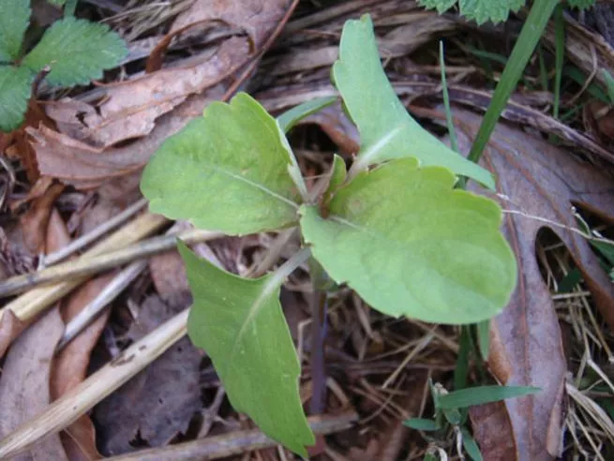
Arrowroot

beechnut
Blackberry

Burdock flower

Buttercup

Cattail

Chicory

Daffodil

Dandelion

Elderberry

Fox glove

Holly

Meadow death

Milkweed

Morning glory

Mulberry

Yarrow

Poison hemlock

Poison oak

Poison ivy

Poke weed

Rose hips

Sassafrass

Stinging nestle

Sugar maple

Sumac

Trumpet vine

Wild garlic

Wild leek

Wild strawberry

Lavender

Lemon Balm
Plantain

Purple Coneflower
Echinacea
Black Walnut

Birch Bark

